**DC Motor :**

#include <reg51.h>

sbit motor_pin1 = P1^0;

sbit motor_pin2 = P1^1;

sbitbutton_reverse = P2^0;

bit motor_direction = 0;

void delay(unsigned int time) {

unsigned int i, j;

for(i = 0; i< time; i++) {

for(j = 0; j < 1275; j++);

}}

void low_speed_delay(unsigned int time) {

unsigned int i, j;

for(i = 0; i< time; i++) {

for(j = 0; j < 100000; j++); // Increase delay significantly to slow down motor

}}

void main() {

motor_pin1 = 1;

motor_pin2 = 0;

while(1) {

if(button_reverse == 0) {

delay(50);

while(button_reverse == 0);

motor_direction= !motor_direction;

if(motor_direction == 1) {

motor_pin1 = 0;

motor_pin2 = 1;

} else {

motor_pin1 = 1;

motor_pin2 = 0;

}

delay(50);

}

motor_pin1 = 1;

motor_pin2 = 0;

low_speed_delay(10); // Motor ON for a long time to achieve low speed

motor_pin1 = 0;

motor_pin2 = 0; // Motor OFF to simulate slow rotation

low_speed_delay(10); // OFF delay to reduce effective RPM

}}

**Interfacing Diagram :**

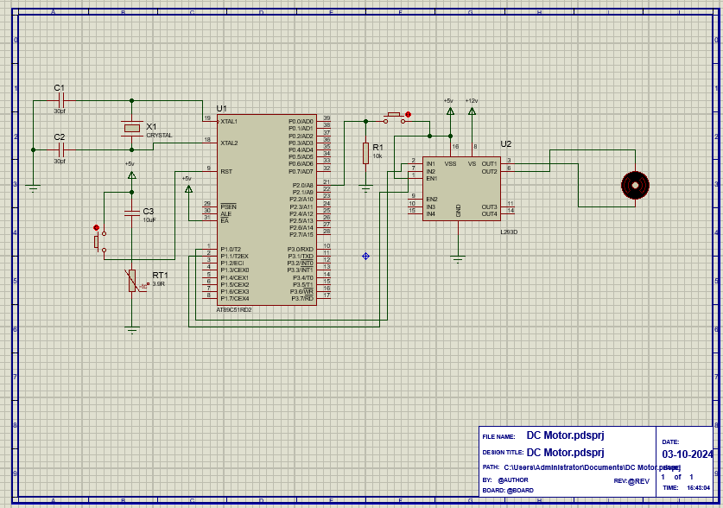

**Output:**

